User Manual

Agile Software Development Assignment

**ABOUT APPLICATION**

This application is a software tool which allows users to store their skills, education history, work experience and job information. Thanks to this application the user will have everything they need, in one place, to make writing CVs and covering letters easy.

This user guide presents an overview of the application’s features and gives step-by-step instructions for completing a variety of tasks.

**SYSTEM REQUIREMENTS**

To run this software you will need Python version 3 or higher and pyQT 5.

**DISPLAY RECQUIREMENTS**

This application will display correctly on 100% screen text size. On higher values text may be unreadable. For full experience we recommend using 100% text size. To change or check the text size on Windows 10 computer you can go to Start > Settings > System > Screen > Scale and Layer > Change the size of text apps and other items.

**SOFTWARE INSTALLATION**

Unpack the .rar file wherever you want. Then you can create shortcut to window_controller.py (this is the main file to open the application). After unpacking and creating a shortcut the application is ready to be used.

**GETTING STARTED**

This is the first page you will see when opening the application:

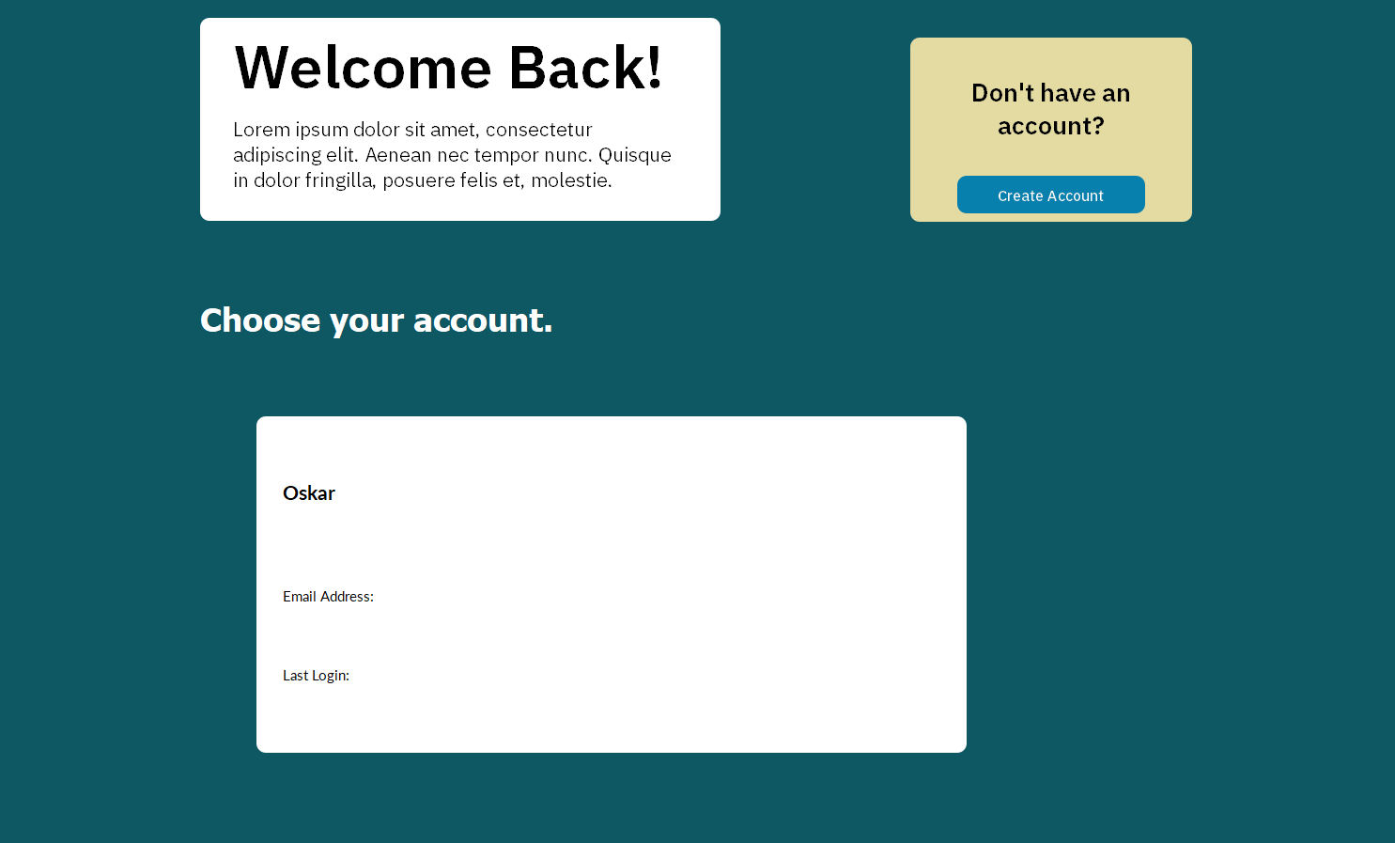

* **To create an account,** click Create Account.
* **To login,** click one of the accounts on the bottom of your screen.

This will take you to the login screen.

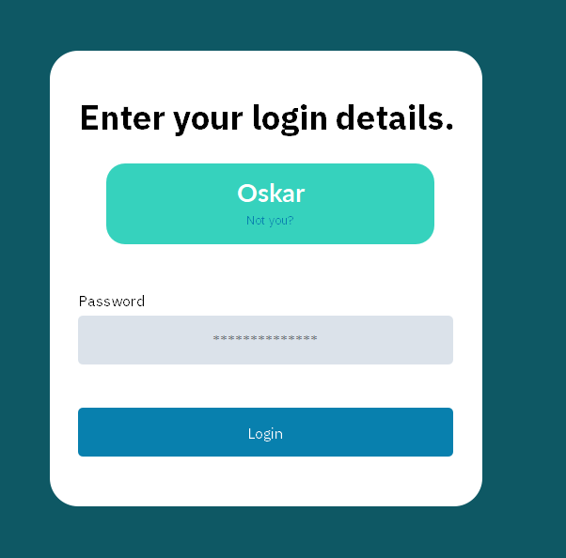

* **To login,** enter your password and click Login.

**EXPLORING THE START PAGE AND MENU**

The start page is a convenient hub to all the parts of our Application:

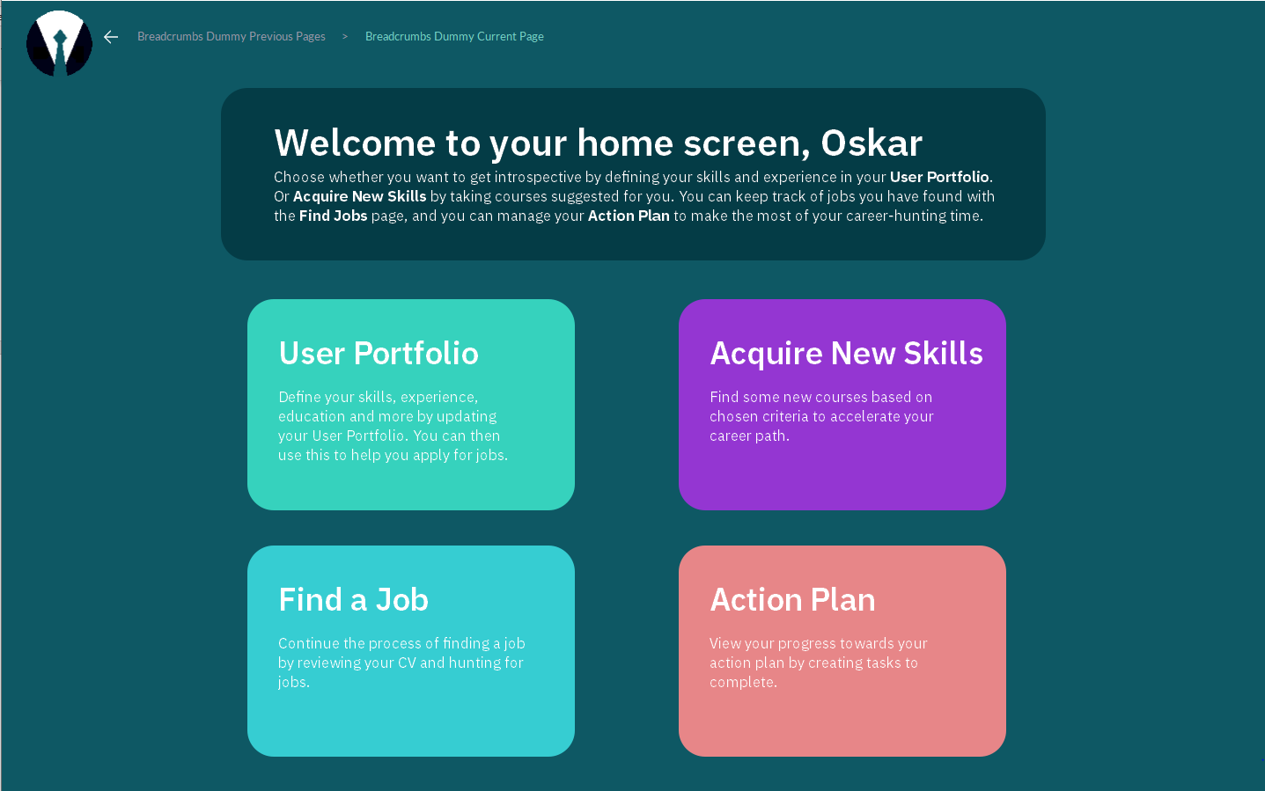

* **To open User portfolio,** click User Portfolio.
* **To open Jobs Menu,** click Find a Job.
* **To open Skill Resources,** click Acquire New Skills.
* **To open your Action Plan,** click Action Plan.
* **To open Menu,** click icon in top.

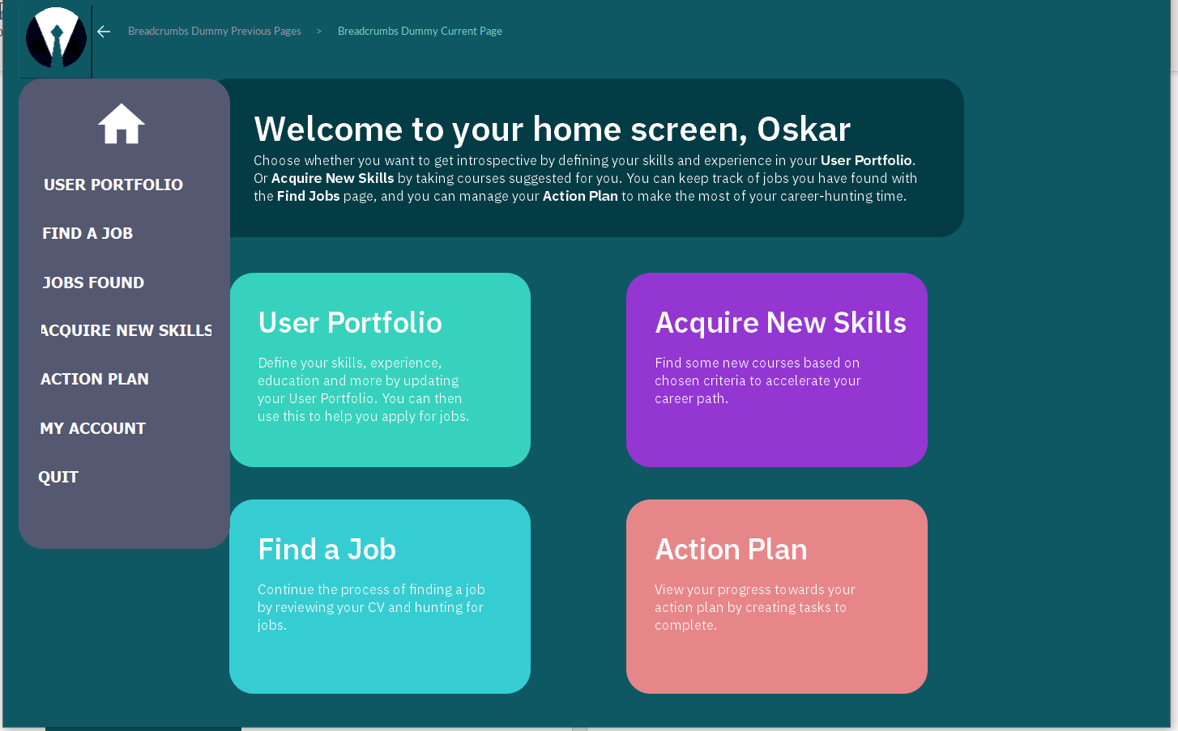

This is the main page with the menu opened. You can access most places in the program from this menu. The menu is also available to you from any place in the program. This way you do not have to go through the main page to access other pages.

**USER PORFOLIO**

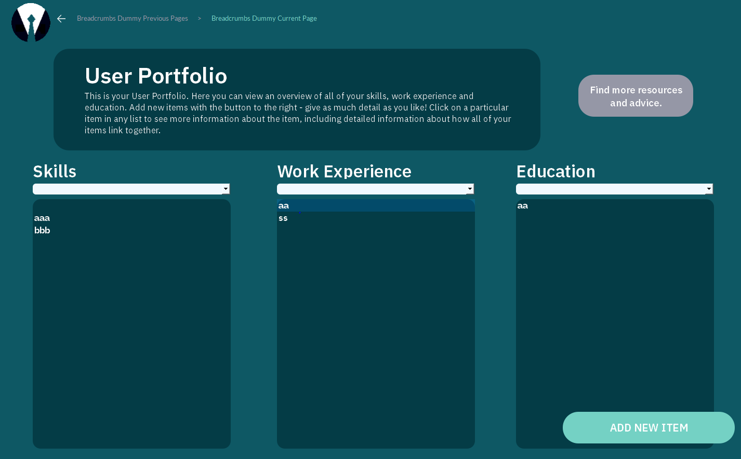

This is the user portfolio page. It has all your inputted skills, work experience and education.

If you want to access any of the items to view it in more detail, click them directly on the item and it will display more information.

To add a new Item in this list click ADD NEW ITEM. A small window will pop up in which you can choose which item you would like to add.

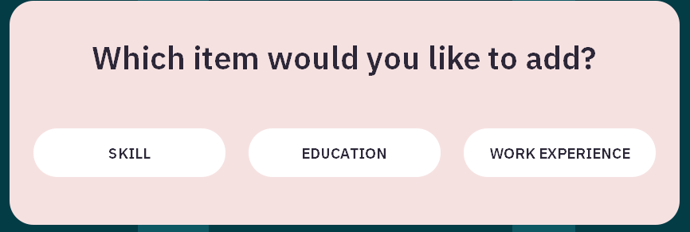

Then it will take you to the ‘adding page’ where you can add multiple items at once.

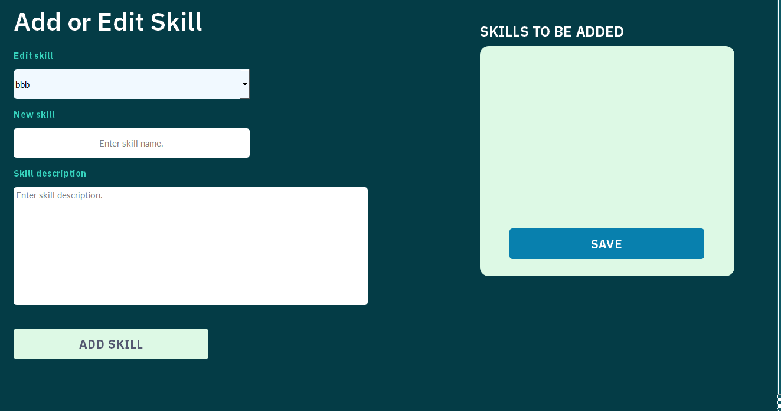

This is one of those pages.

To add new skill: enter the name in New Skill box then add its description below. Then click add skill. All the skills you input should display in skills to be added list. When you click save skill(s) will be added to the portfolio. Experience and Education work exactly the same.

**ACQUIRE NEW SKILLS**

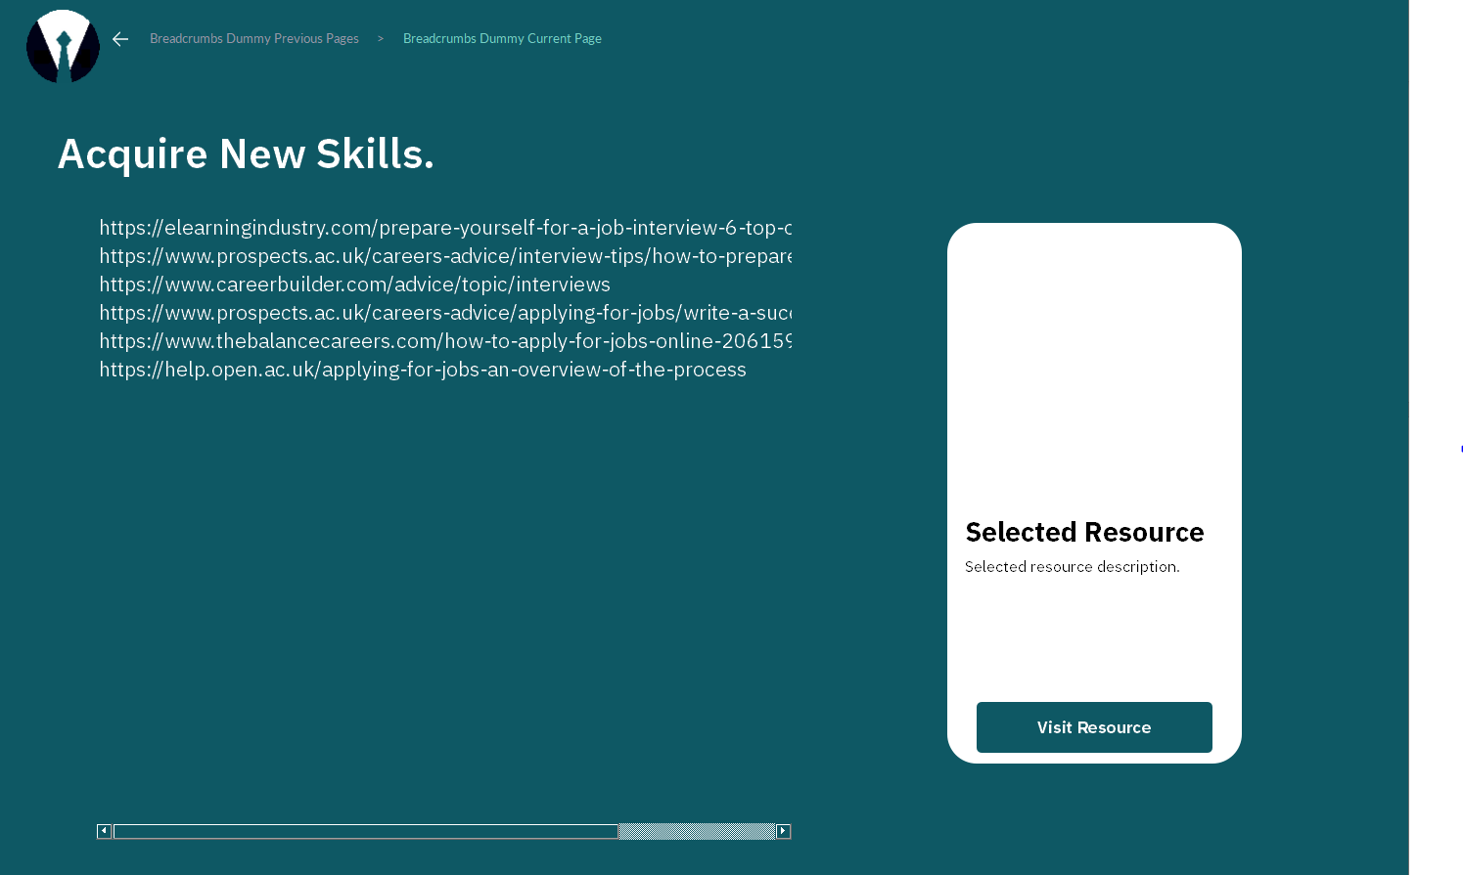

This Page will help you acquire new skills. You can access the resources we chose and access them by clicking on the resource to visit it in your web browser. This will take you to the web page where you can learn something new and useful.

**Jobs**

This module of the app supports you with resources on how to find a job (Find a Job), and lets you keep track of any jobs you have found (Jobs Found). . After entering through main screen you will see the respective buttons for each page.

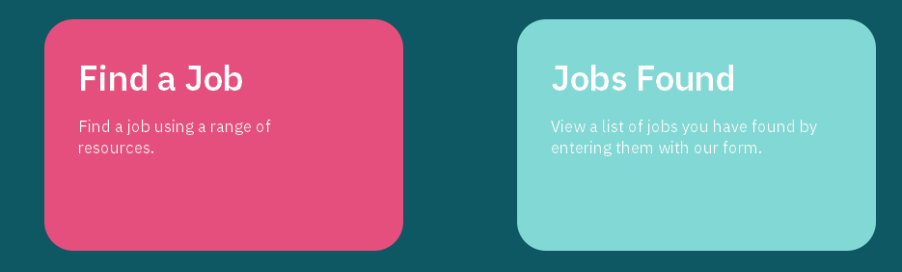

**Find a Job** module works the same as the acquire new skills. This will have resources inputted by us for you to look through and learn something about getting a job.

**Jobs Found** module is a module that helps you keep track of the jobs you have found by displaying them in a list.

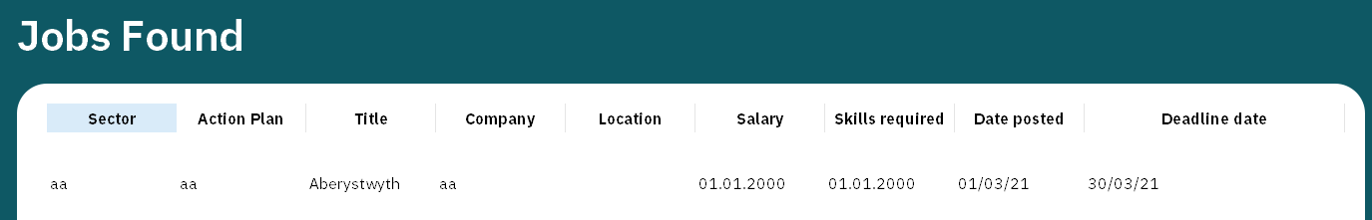

In this module you can add new jobs by clicking the Add New Job button in the bottom right corner.



This will take you to the Add Page that works like pages in portfolio, but you can only add one job at the time.

By double clicking on the Jobs Found list you will go to this job page. This page will display more information about the given job. On this page you will have possibility to edit it or add it to action plan if you intend to apply to the job .

**Action plan**

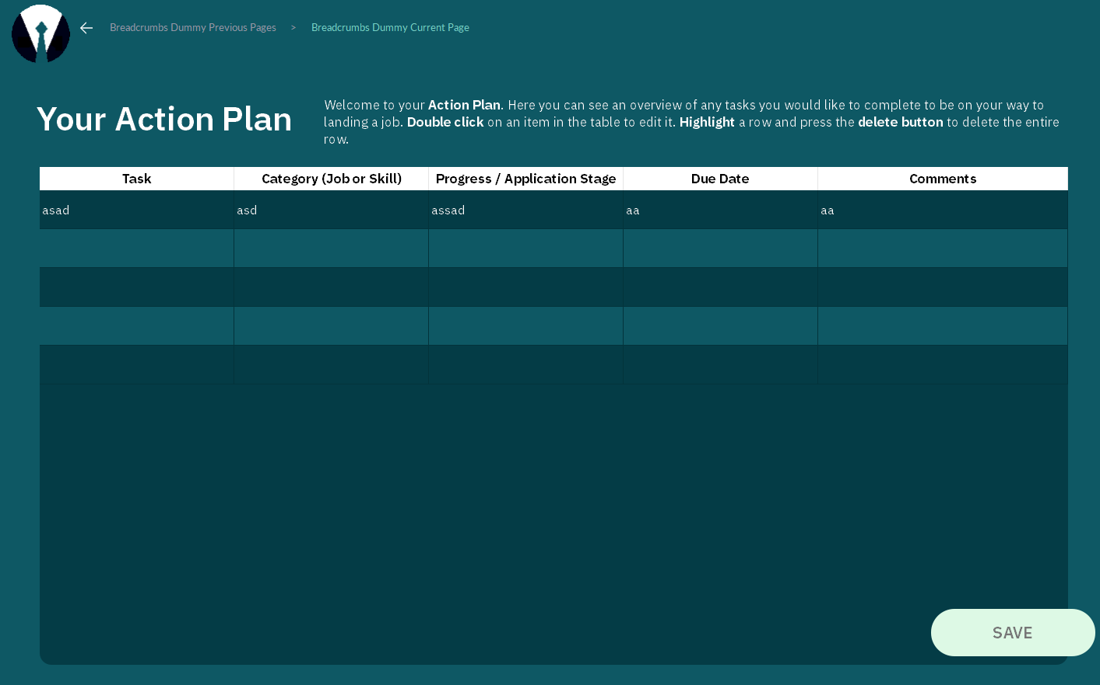

This is the page where you can plan your future. Here you can keep track of all the things you are learning and all the jobs you want to apply for. To add or edit the tasks you can input them right on this page in the table. Then you need to click SAVE button to save your input.

**MY ACCOUNT**

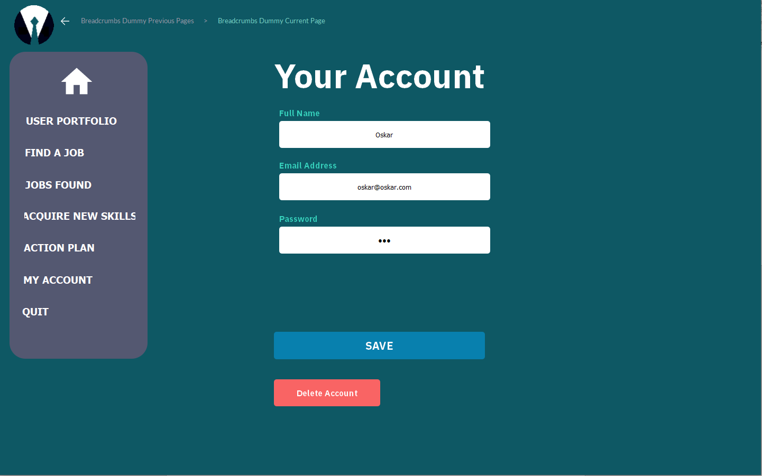

This Page is accessible only from the menu with the MY ACCOUNT button. In here you can change your details or delete the account you are currently using.